- Prof. Brooke Erin Duffy  Associate Professor  Email: bduffy@cornell.edu  Virtual Office hours (Join through the “Zoom” link in Canvas):  Mon: 2:30-3:30 PM  Tues: 1:00-2:00 PM  TEACHING ASSISTANTS  (Team Assignments Noted in Parentheses)  Graduate TAs  **Office Hours via Zoom  Emily La (1-3)  Senior TA for A-Le  Lucas Wright (4-6)  Senior TA for Li-Z  Undergraduate TAs  Sophie Levine (7-9)  Danielle Luntz (10-12)  Elena Pertsalis (13-15)  Stephen Yang (16-18) | Comm/Info 3200  New Media + Society  Updated 2/15/2021  T/TH 2:45PM - 4:00PM EST  Synchronously via Zoom  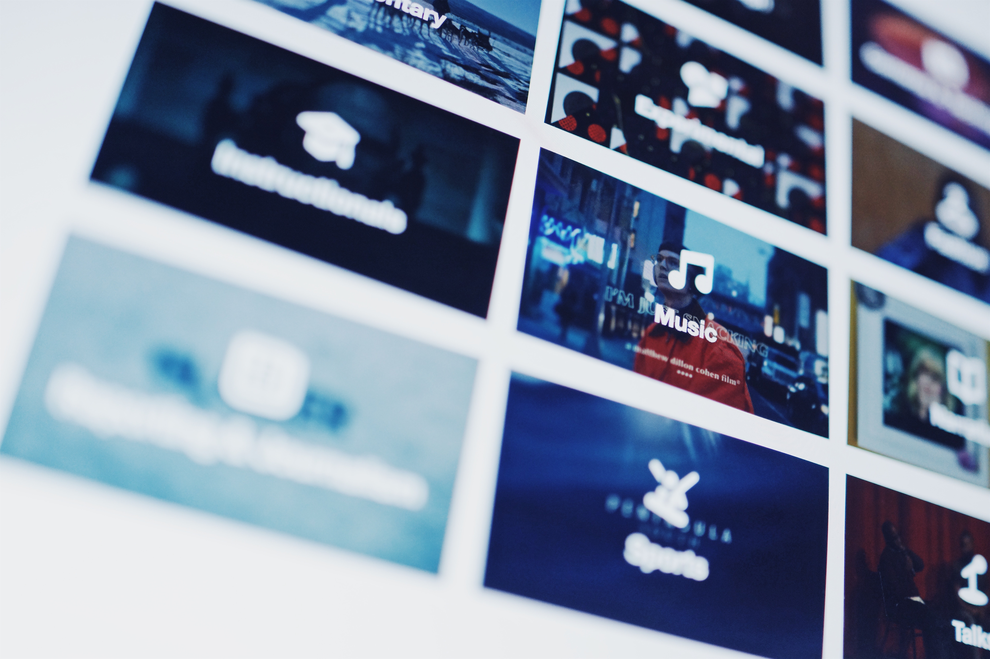  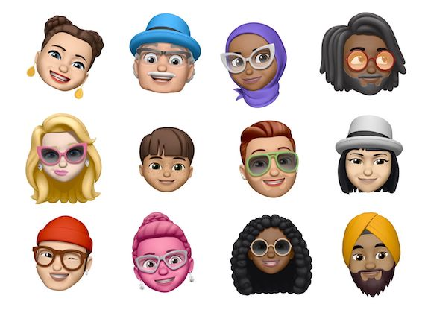  CORNELL UNIVERSITY  SPRING 2021  Course Twitter: @CUComm3200
- Learning Objectives  The learning objectives of this course include to:  1) develop analytical tools for understanding the complex information society;  2) examine how the cultural, political, and economic environments are changing with the emergence of new media and digital technologies;  3) encounter and address pressing contemporary controversies in the legal, political, and cultural realms;  4) develop a voice on these issues, expressed in relevant new media formats. | Course Overview  We are immersed in a complex and pervasive media culture, which makes it difficult for us to recognize the intricate relationship between media, technology, and society. Indeed, what we see, hear, read, and experience are largely a product of our society and its particular political, economic, material, and cultural configuration. This relationship also shapes our understanding of ourselves, our society, and the world around us. Yet, our media culture is undergoing a profound series of transformations – as new technologies, new forms of entertainment, new venues for political debate, and new models of participation and labor emerge online.  This course will interrogate how the social, political-economic, and cultural landscape is changing in relation to digital media and information technologies. We will develop critical resources to better understand the history of these technologies and emerging communicative forms; the economics and politics behind them; the sociocultural moments from which they have emerged; and the shifts they have engendered. Once equipped with these tools, we will ask deeper questions about their impact on society.  CONTEXT INDUSTRY  IDENTITY POLITICS CULTURE
- Grading  - Essays (3 x 50 pts.) 30 %  - Discussion Posts (4 x 20) 16 %  - Exam 1 (100 pts) 20%  - Exam 2 ( 100 pts ) 20%  - Attendance/Participation  - (25+25=50pts.) 10%  - Twitter Discussion 20 4%  - Total 500 100%  - Grade Scale  - A+ = 98+  - A = 94-97.5  - A- = 90-93.5  - B+ = 87-89.5  - B = 84-86.5  - B- = 80-83.5  - C+= 77-79.5  - C = 74-76.5  - C- = 70-73.5  - D+= 67-69.5  - D = 64-66.5  - D- = 60-63.5  - F 60  - Extra Credit  To gain a deeper understanding of the research process, students are encouraged to participate in a Communication or Information Science research study at Cornell. Information about the studies is available through the Communication/IS SONA system: https://cornell-comm.sona-systems.com SONA points are given out based on 30-minute time intervals. One SONA point (or one 30-minute offline study) is equivalent to 2.5 extra credit points (.5%) in this course. Students may earn up to 7.5 extra credit points (1.5% of the total grade) for 3 SONA points.  Students can also earn extra credit for attending a virtual academic event (i.e. colloquium, special lecture, etc.) I will announce lectures/events which fit with the course material. After attending, students must write a 1/2-page report summarizing the lecture and relating it new media and society. One lecture reflection will be worth 5 extra credit points (1% of grade). These should be submitted to your graduate TA.  While students may do any combination of research extra credit and lecture report extra credit, they may not earn more than a total of 7.5 course points (1.5% of the total grade). Also, please note that these are the only possibilities for extra credit; please do not ask if I can give “you” extra credit or make up exam/assignment points as this would be unfair to your peers | READING  The most important assignment is to complete all of the readings in advance of the class period in which they will be discussed; comprehension of these materials is crucial to your success in this course. These readings will come up in class discussion, and you will be expected to have not just read them, but digested them, drawing insights, ideas, and questions from them to help fuel our conversation in class. You will also be expected to discuss them within your assigned teams, so be sure to come to class prepared. Recommended readings are suggestions for important scholarship related to a particular topic or theme. However, the material will not appear on exams and you are not required to engage with it in discussion posts (although you are welcome to!)  ESSAYS  In order to delve deeper into critical issues at the juncture of digital media and society, you will be responsible for submitting three essay assignments on the following topics:  1. Social Media Deprivation  2. Algorithms, Data, and Personalization  3. Social Media Self-Presentation  Essays should be approximately 6 pages in length, and all references must be cited appropriately using APA formatting. Additional details on these assignments will be provided in class. Essays must be submitted via Canvas (using TurnItIn) by 11:00 AM on the due date. Missed deadlines will be assessed a deduction of one third of a letter grade per day (e.g. from A- to B+ for 1 day late). The penalty for lateness begins immediately after the assignments have been collected on the due date.  ATTENDANCE AND PARTICIPATION  Starting in the second week of classes, participation will be taken during each class meeting. While I strongly encourage you to come to every class, you are allowed three “free” absences. There is no need to let your grading TA know if you will not be in class. If you miss more than three classes for ANY reason (other than a documented medical/family emergency), your participation/attendance grade by 5 points per absence.  If you do miss a class, you are responsible for finding out what we covered from a classmate in advance of the next course meeting.  In addition to attending class, you are also required to participate—both individually and as part of your Teams (see below). I want to hear everyone’s voice in this class at least once. You can also boost your participation points by coming to meet with me/your TAs in office hours and thoughtfully discussing course material.  TEAMS  During the first week of class, you will be assigned to a small team of 4-5 members. You will meet regularly with your team within “breakout rooms,” and each team will be called upon throughout the semester to share discussions and the output of group activities. As such, you may want to appoint a team discussant, although I encourage all members to participate. In addition, each team will have an assigned TA who will help to moderate the discussions.  EXAMS  Your understanding of the course material will be assessed through a (1) mid-term examination given in class halfway through the semester and (2) a final exam on the last day of class. The exam will be based on material from the book, assigned articles, class discussions, and any videos shown in class. The format is multiple choice, short answer, and essay.  The exams must be taken on scheduled date. Make-up exams will only be scheduled in the event of an extreme emergency and must be discussed with the professor before the scheduled exam date. In such a case, written documentation of the emergency will be required.  DISCUSSION POSTS  Throughout the semester, you will be responsible for submitting four discussion posts on Canvas. You will be assigned to a group (A,B,C,D) early in the semester, and the due date for each group is listed on the syllabus. Your online discussion requires you to engage with the assigned readings in greater depth. Your write-up should be between 600 words and should be submitted BEFORE the class for which it is assigned. The write-up will be evaluated based on whether it successfully 1) summarized the reading(s), 2) relate and integrate the readings to each other or to earlier readings, 3) related ideas and arguments from the readings to real life examples, experiences, news stories, links, etc.. These posts should be well written, free from spelling or grammatical errors. These are due before the next class and should be posted to Canvas. Each discussion posting is worth 20 pts for a total of 80 points.  TWITTER  For every class, starting 2/11, you are required to post a response, point of clarification, discussion question, critique, or example based on the readings. This should be posted by 11:59 pm the night before class; you will docked points for lateness. You should direct your tweets to @CUComm3200. Good tweets should do one of four things: 1) summarize the reading(s), 2) relate and integrate the readings to each other or to earlier readings, 3) relate ideas and arguments from the readings to real life examples, experiences, news stories, links, etc., or 4) identify particularly problematic, challenging, or fascinating parts of the readings to dissect collectively. Remember that tweets are “public,” and I will regularly “feature” Tweets on the class PowerPoint/lecture.  Each tweet is worth 1 pt. for a total of 20 points. If you have to miss class due to illness or an official university activity, you should still tweet about the readings. You can only get one point per Tweet per class; if you Tweet several times about the readings, only the first one will be graded.  CLASS POLICIES  Course Communication  Given the size of the course, you should consult with your undergraduate TA for questions about logistics, resources, and help understanding the material. You should consult with your graduate TA about emergency class absences, your exams, and grading concerns. I generally check my email first thing in the morning. I will make every effort to respond to your email within 24 hours, Monday-Friday. Thus, please do not leave important questions for Friday evening.  Please be sure you check your email and Canvas regularly for updated/additional readings as well as course announcements.  The Zoom Classroom  The virtual classroom, much like the face-to-face one, should be a courteous, respectful and productive space. I encourage you to share your thoughts (using the hand function to “raise your hand”) and participate in group chat (TAs will monitor this, and I’ll do my best to engage with the chat discussions, too).  While I do not require you to have your camera on, the teaching and learning experience will be improved if you are able to show your faces to me and your peers. I realize that life happens, so do not worry if family members, friends, or pets appear in the background; mine surely will throughout the semester. It’s also likely that the technology will fail throughout the semester. Monitor your email and Canvas for instructions on how to proceed.

UNIVERSITY POLICIES

Students with Academic Accommodations
If you are a student with a disability and qualify for academic accommodations, please contact me as early as possible during the semester. I am happy to provide students with the necessary accommodations. If testing accommodations are made, you are required to show up within 10 minutes of your pre- arranged start time or I will assume that you did not need the accommodation and, if regular exam has already passed, you will forfeit your exam.
Statement of Inclusivity and Respect
Students enrolled in this course represent a rich variety of backgrounds and perspectives that are unique and valuable. I am committed to providing an atmosphere for learning that is inclusive, respects diversity, and promotes equity. We will treat students of all backgrounds including race, ethnicity, gender, sexual orientation, nationality, immigration status, religion, and political ideology fairly and with honesty, integrity, and respect. While working together to build a supportive and inclusive learning environment in this course, I ask everyone to:
- Share their unique experiences, values and beliefs.
- Be open to the views of others.
- Honor the uniqueness of their colleagues.
- Appreciate the opportunity that we have to learn from each other in this community.
- Value each other’s opinions and communicate in a respectful manner.

Academic Dishonesty
The Communication Department constituents hold each other to the highest standards of academic integrity and uphold the University policies of Academic Integrity. In accordance with Communication Department AI Policy, any student in this class suspected of plagiarism or cheating on tests or assignments will have a primary hearing. If found guilty, the student will receive a failing grade on the assignment in question and a reduction in the overall course grade, and the results of the hearing will be reported to the CALS Academic Integrity Board. The Communication Department’s policy is based on university-wide policy and procedures. Visit the University Academic Integrity website for further information.
ALL WORK MUST BE YOUR OWN and MUST BE UNIQUE TO THIS CLASS (not completed in/for another class). Any work that is not your own and is not cited, and any work that has been completed in whole or part for another course will receive a ZERO.

Turn It In

Students agree that by taking this course all required papers may be subject to submission for textual similarity review to Turnitin.com for the detection of plagiarism. All submitted papers will be included as source documents in the Turnitin.com reference database solely for the purpose of detecting plagiarism of such papers. Use of the Turnitin.com service is subject to the Usage Policy posted on the Turnitin.com site.
Course Schedule (please note this may be slightly modified for pedagogical purposes)
DATE | MODULE: Topic | Reading/Materials | Assignment Due
Feb 9 | INTRODUCTION: Course Overview | Entire Syllabus  Lefkowitz, M. (2021). Appearance, social norms keep students off Zoom cameras. Science Daily, Retrieved from: https://www.sciencedaily.com/releases/2021/01/210119194320.htm  Recommended (Full Study): Castelli, M. & Sarvary, A. (2021). Why students do not turn on their video cameras during online classes and an equitable and inclusive plan to encourage them to do so. Ecology and Evolution, DOI: 10.1002/ece3.7123
Feb 11 | CONTEXT: Orienting Debates about Tech and Society | Baym, N. (2015). Making new media make sense. In Personal Connections in the Digital Age, 2nd Ed. (pp. 24-52 only). Cambridge, UK: Polity Press.  Orlowski, J. (2020). The social dilemma [documentary]. Netflix. (Available at Netflix or via Documentary Era.TV). ***Watch before Malhotra  Malhotra, P. (2020, September 18). The social dilemma fails to tackle the real issues in tech. Slate, Retrieved from www.slate.com | First Tweet Due!  Add Twitter handle to Google Forms
Feb 16 | CONTEXT: Platforms and Affordances | Bucher, T., & Helmond, A. (2017). The affordances of social media platforms. The SAGE handbook of social media, 233-253.  Galer, S. S. (2020, December 16). How TikTok changed the world in 2020. BBC Culture. Retrieved from: https://www.bbc.com/culture/  Recommended: Van Dijck, J., & Poell, T. (2013). Understanding social media logic. Media and communication, 1(1), 2-14. | GROUP A DISCUSSION
Feb 18 | CONTEXT:  Historicizing “New Media” | Humphreys, L. (2018). Performing identity work. In The qualified self: Social media and the accounting of everyday life. Cambridge, MA: MIT Press.  Standage, S. & Stevenson, S. (2019). The secret history of new media [podcast]. Slate. Retrieved from: https://slate.com/podcasts/ | GROUP B  DISCUSSION
Feb 23 | CONTEXT:  A Brief History of New Media | Stevenson, M. (2018). From hypertext to hype and back again: Exploring the roots of social media in the early web. In J. Burgess, A Marwick and T Poell (eds.). The SAGE Handbook of Social Media. Sage Press.  Hicks, M. (2017, August 9). Memo to the Google memo writer: Women were foundational to the field of computing. The Washington Post. Retrieved from www.washingtonpost.com  Recommended: Marantz, A. (2019, September 30). The Dark Side of Techno-Utopianism. The New Yorker.
Feb 25 | INDUSTRY: Economies of New Media | Smirnek, N. (2017). Introduction and Chapter 1. Platform Capitalism. Pp 1-20.  Marvin, G. (2013, October). Blockbusters”: Why the long tail Is dead and go-big strategies pay off. Marketing Land. Retrieved from: https://marketingland.com/blockbusters-why-the-long-tail-is-dead-and-go-big-strategies-pay-off-62763  Dewey, C. (2015). “You don’t know it, but you’re working for Facebook. For free.” The Washington Post.  Recommended: Nieborg, D. B., & Helmond, A. (2019). The political economy of Facebook’s platformization in the mobile ecosystem: Facebook Messenger as a platform instance. Media, Culture & Society, 41(2), 196-218. | ESSAY 1 DUE  FEB 28, 11:59 PM
Mar 2 | INDUSTRY: Automation and Algorithms | Napoli, P. M. (2014). On automation in media industries: Integrating algorithmic media production into media industries scholarship. Media Industries 1(1). 1-13.  Chaya, K. (2019, December 17). Can monoculture survive the algorithm? And should it? Vox. Retrieved from www.vox.com | GROUP C DISCUSSION
Mar 4 | INDUSTRY: Labor in New Media Industries | Deuze, M., & Prenger, M. (2019). Introduction. Making media: Production, practices, and professions (pages 13-23 only). Amsterdam University Press  Meisner, C., & Ledbetter, A. M. (2020). Participatory branding on social media: The affordances of live streaming for creative labor. New Media & Society, 1461444820972392.  Silverman, J. (2019, May 2). Down and Out in the Gig Economy. The New Republic. | GROUP D DISCUSSION
Mar 9 |  | NO CLASS-WELLNESS DAY
Mar 11 | INDUSTRY: The Future of Journalism | Christin, A., & Petre, C. (2020). Making peace with metrics: Relational work in online news production. Sociologica, 14(2), 133-156.  Lepore, J. (2019, January 28). Does Journalism Have a Future? The New Yorker. Retrieved from: https://www.newyorker.com/magazine/2019/01/28/does-journalism-have-a-future | GROUP A  DISCUSSION
Mar 16 | IDENTITY: Gender | Grindstaff, L. A. (2020). Selfies and postfeminism. The International Encyclopedia of Gender, Media, and Communication, 1-5.  Butkowski, C. P., Dixon, T. L., Weeks, K. R., & Smith, M. A. (2020). Quantifying the feminine self (ie): Gender display and social media feedback in young women’s Instagram selfies. New Media & Society, 22(5), 817-837.  Garlick, H. (2020). Why gender stereotypes are perpetuated on Instagram. The Financial Times.  Recommended: Banet-Weiser, S. (2018). Empowered: Popular feminism and popular misogyny. Durham, NC: Duke University Press. | GROUP B  DISCUSSION
Mar 18 | IDENTITY: Race | Noble, S. (2018). Google has a striking history of bias against black girls. Time. Retrieved from: https://time.com/5209144/google-search-engine-algorithm-bias-racism/  Parham, J. (2019). TikTok and the evolution of digital blackface. Wired. Retrieved from: https://www.wired.com/story/tiktok-evolution-digital-blackface/  Basu, T. (2020, June). Asian-Americans are using Slack groups to explain racism to their parents. MIT Technology Review. Retrieved from: https://www.technologyreview.com/2020/06/22/1004312/asian-americans-are-using-slack-groups-to-explain-racism-to-their-parents/  Florini, S. (2014). Tweets, Tweeps, and Signifyin’ Communication and Cultural Performance on “Black Twitter”. Television & New Media, 15(3), 223-237.  Recommended:  Brock, A. (2020). African American cybercultures: The Black Purposes of Space Travel”: Black Twitter as Black Technoculture. In Distributed blackness: African American Cybercultures. New York. New York University Press. | GROUP C  DISCUSSION
Mar 23 | IDENTITY:  IDENTITY: Sexuality | GUEST SPEAKER: COLTEN MEISNER  Duguay, S. (2016). “He has a way gayer Facebook than I do”: Investigating sexual identity disclosure and context collapse on a social networking site. New Media & Society, 18(6), 891-907.  Agüera y Arcas, A. Todorov, and M. Mitchell. (2018). Do algorithms reveal sexual orientation or just expose our stereotypes?”. Medium essay. Retrieved 28 January 2018 | ESSAY 2 DUE
Mar 25 | IDENTITY: Intersectionality and Vulnerability | Lawson, C. E. (2018). Platform vulnerabilities: Harassment and misogynoir in the digital attack on Leslie Jones. Information, Communication & Society, 21(6), 818-833.  Burns, K. (2019, December 27). The internet made trans people visible. It also left them more vulnerable. Vox.  Jennings, R. (2020). The paradox of online “body positivity. Vox. Retrieved from: https://www.vox.com/
Mar 30 |  | MID-TERM EXAM
Apr 1 | POLITICS:  The Public Sphere | Papacharissi, Z. (2016). On networked publics and private spheres in social media. In Hunsinger, J. and Senft, T. The Social Media Handbook. New York: Routledge.  Freelon, Goodwin, D. McIlwain, D. and Clark, M. (2016). Beyond the Hashtags:  #Ferguson, #BlackLivesMatter, and the Online Struggle for Offline Justice. Washington, DC: Center  for Median and Social Impact, School of Communication, American University, 2016. (skim) | GROUP D  DISCUSSION
Apr 6 | POLITICS: Hashtag Activism | GUEST LECTURE: EMILY LA  Gladwell, M. (2010). Small Change: Why the Revolution Will Not Be Tweeted The New Yorker.  Jackson, S. (2019). Twitter Made Us Better. New York Times.  Appiah, K. (2020, June 30). I’ve protested for racial justice. Do I have to post on social media? The New York Times Magazine. | GROUP A  DISCUSSION
Apr 8 | POLITICS: Governance of Platforms | GUEST SPEAKER: LUCAS WRIGHT  Gillespie, T. (2018). Governance of and by platforms. In J. Burgess, A. Marwick, and T. Poell (eds.). The Sage Handbook of Social Media. Sage Press. (FIRST 8 PAGES)  Remnick, D. (2021, February). The supreme court of Facebook. The New Yorker. Retrieved from https://www.newyorker.com/podcast/the-new-yorker-radio-hour/the-supreme-court-of-facebook  Newton, C. (2020, December 20). Everything you need to know about Section 230. The Verge. | GROUP B  DISCUSSION
Apr 13 | POLITICS:  Governance by Platforms | Gillespie, T. (2018). Governance of and by platforms. In J. Burgess, A. Marwick, and T. Poell (eds.). The Sage Handbook of Social Media. Sage Press. (SECOND HALF)  Cook, J. (2019, April). Instagram’s Shadow Ban On Vaguely ‘Inappropriate’ Content Is Plainly Sexist. Huffington Post.  Weber, L. & Seetharaman, A. (2017). The worst job in technology: Staring at human depravity to keep it off Facebook. Wall Street Journal Online.  Lewis, B. (2021, January). The Trump ban across social media wasn’t censorship — it was a series of editorial decisions by media companies that call themselves social platforms. Business Insider,  Recommended: Roberts, S. (2019). Behind-the-Screen. Content Moderation. New Haven, Yale University Press. | GROUP C  DISCUSSION
Apr 15 | POLITICS:  Alternative Spaces, Alternative Facts | Vaidhyanathan, S. (2021 January). Making Sense of the Facebook Menace. The New Republic.  Marwick, A., & Lewis, R. (2017). Media manipulation and disinformation online. New York: Data & Society Research Institute.  Misreale, C. (2018, May 9). How misinformation spreads on social media—And what to do about it. Brookings Institute: https://www.brookings.edu/blog/order-from-chaos/2018/05/09/how-misinformation-spreads-on-social-media-and-what-to-do-about-it/  Recommended: Clark-Parsons, R., & Lingel, J. (2020). Margins as methods, margins as ethics: A feminist framework for studying online alterity. Social Media+ Society, 6(1), 2056305120913994. | GROUP D  DISCUSSION
Apr 20 | CULTURE: Privacy and Surveillance | Draper, N. A., & Turow, J. (2019). The corporate cultivation of digital resignation. New Media & Society, 21(8), 1824-1839.  Duffy, B. E., & Chan, N. K. (2019). “You never really know who’s looking”: Imagined surveillance across social media platforms. New Media & Society, 21(1), 119-138  Eubanks, V. (2014). Want to Predict the Future of Surveillance? Ask Poor Communities. The American Prospect  https://www.nytimes.com/2021/02/05/us/colleges-social-media-discipline.html | GROUP A  DISCUSSION
Apr 22 | CULTURE: Online Communities and Fandom | Jenkins, H., Ford, S., & Green, J. (2018). What constitutes meaningful participation. In Spreadable media: Creating value and meaning in a networked culture (Vol. 15). NYU press. *swapped  Baym (2018, July 10). How music fans built the internet (Excerpt from Playing to the crowd). Wired.
Apr 27 | CULTURE: Dating and Relationships | Quinn, K. & Papacharissi, (2018). Networked selves: Personal connection and relational maintenance in social media use. In J. Burgess, A. Marwick and T. Poell (eds.). The Sage Handbook of Social Media. Sage Press.  MacLeod, C., & McArthur, V. (2019). The construction of gender in dating apps: An interface analysis of Tinder and Bumble. Feminist Media Studies, 19(6), 822-840.  Recommended: Tiidenberg, K. and van der Nagel, E. (2020), "Sex, Communities, and Relationships on Social Media", Sex and Social Media (Society Now), Emerald Publishing Limited, pp. 135-161. | Essay 3 DUE
Apr 29 | CULTURE:  Social Media Self-Presentation | Whitmer, J. M. (2019). You are your brand: Self‐branding and the marketization of self. Sociology Compass, 13(3), 1-10.  Tiffany, K. (2020, May). The Secret Lives of Perfect Social Distancers. The Atlantic.  Padilla, M. (2019, July). Instagram is hiding likes. Will it reduce our anxiety? New York Times.  Black Mirror: Nose Dive (Netflix)  Recommended: Hearn, A. (2017). Verified: Self-presentation, identity management, and selfhood in the age of big data. Popular Communication, 15(2), 62-77. | GROUP B  DISCUSSION
May 4 | CULTURE: Creators and Influencers | Craig, D., & Cunningham, S. (2019). Social media entertainment: The new intersection of Hollywood and Silicon Valley [excerpts]. NYU Press.  Lorenz, T. (2020). Trying to Make It Big Online? Getting Signed Isn’t Everything. The New York Times.  Recommended: Bishop, S. (2019). Managing visibility on YouTube through algorithmic gossip. New Media & Society, 21(11-12), 2589-2606. | GROUP C  DISCUSSION
May 6 | CULTURE: Social Media (In)Famy | Duffy, B.E., Miltner, K, and Wahlstedt, (2021). “Fake” femininity: Influencer Anti-fandom. New Media & Society(in press)  Munro, C. 2020). Meet the New Social Media Stars Making A Hobby of Dismantling Influencer Culture. Refinery 29. Retrieved from: https://www.refinery29.com/  Ross, L. J. ( 2019, August 17.) I’m a Black Feminist. I Think Call-Out Culture Is Toxic. The New York Times. https://www.nytimes.com/2019/08/17/opinion/sunday/cancel-culture-call-out.html | GROUP D  DISCUSSION
May 11 | TOPIC TBA | CATCH UP CLASS/  ADDITIONAL READINGS TBA
May 13 | FINAL EXAM DURING CLASS

